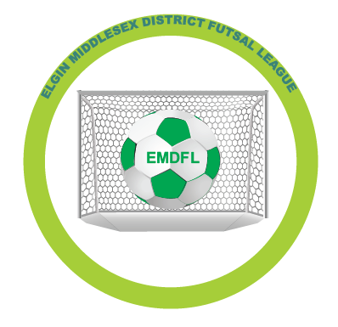
Elgin Middlesex District Futsal League
Youth Development Program
Start Date – Weekend of January 11, 2020
Duration – 10 weeks. Program will run for 10 weeks to March 14 conditional on gym availability
Session durations – 90 minutes. Each session will contain 30 minutes of skills and drills followed by game.
Game structure – After skills sessions players will be divided into two teams for play.
Participant age – Open to players born in 2010, 2011 and 2012. Co-ed.
Cost - $95.
Day of week – Saturdays. Program will run every Saturday. If there is demand for Sunday program additional sessions will be added.
Equipment – Players must have indoor (futsal) gym shoes, shorts/shirt, shinpads. Pinnies will be provided for games.
Benefits of futsal:
https://www.soccertoday.com/why-futsal-is-great-for-youth-soccer-players/
https://www.truefutsal.com/Default.aspx?tabid=823733
https://soccerdebrazil.com/benefits-of-futsal/#targetText=The%20benefits%20of%20futsal%20include,go%201v1%20against%20their%20opponent
Payment to EMSA office. Registration deadline November 23, 2019

Player name - | Contact Name -
Player DOB – YYYY/MM/DD | Contact email -

